ECE 441 Fall 2021

WEEK #13 GROUP MEETING LOG

Lab Session: 2

Group Number: 2

Instructor: Dr. Jafar Saniie

Due Date: 04-13-2022

Acknowledgment: I acknowledge all of the work (including figures and codes) belongs to me and/or persons who are referenced.

Member 1: Alan Palayil

Member 2: Fabian Garcia

Member 3: Gabriel Gutierrez

[Smart Mirror - *Through the Speculum*]

**Project Goal:**

* Create an interactive smart mirror with gesture control, voice commands, and possibly facial recognition.
* Include accessories like LED strips and a sound system.
* Design a compacted design for the 24inch display

**Standards used in Project:**

Not applicable during this stage of the project

**System Constraints:**

* Working around the android 11/12 OS
* Limited to installing and design app

**Prior Knowledge Acquired Critical to Design Project:**

ECE 100, ECE 211, ECE 213, ECE 218, ECE 242, ECE 307, ECE 308, ECE 311, ECE 319, ECE 407, ECE 411, ECE 436, ECE 438, ECE 485, CS 115, CS 116, CS 330, CS 331, CS 350, CS 351, CS 450

Note:

CS 331- Data Structures and Algorithms (Python Programming)

ECE 411: Power Electronics

Meeting 1

| Date | 4/9/2022 |
| --- | --- |
| Start Time | 12:00 PM |
| Duration | 1:30 hour |
| Attendance | All attended |

1. **Agenda**

The team discussed and went over everything that had been completed leading up to ECE Day.

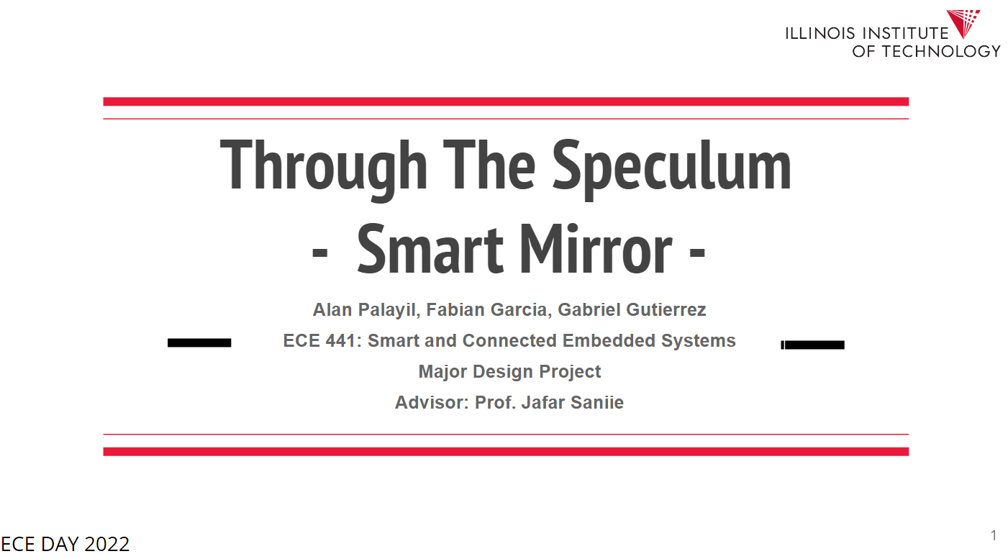

* Android OS is operational
  + Google voice assistant is up and running
  + Additional apps have been installed
  + Raspberry Pi camera module works with 3rd party applications

A group consensus was taken to switch the operating system from Raspbian’s magic mirror software to android OS. This allowed for a more customizable and vibrant device.

**Gabriel:** Got the photo booth program operational, however, further research will be done to get the android counterpart working.

1. **Tasks**

| **1 - Idea development** | | |
| --- | --- | --- |
| **Task** | **Assigned to** | **Due Date** |
| Find additional android OS apps | Everyone | 4/18 |
| Think about enclosure | Everyone | 4/11 |
|  |  |  |
|  |  |  |

1. **Work Distribution**

| **Alan Palayil** | Completed the voice assistants and home automation on the android OS. Tested the limits of Android OS on Raspberry Pi. |
| --- | --- |
| **Fabian Garcia** |  |
| **Gabriel Gutierrez** | Completed and got the photobooth operational. Tested the camera module on other android OS. |

1. **Progress and Milestones**
   1. Presented ECE day
   2. Android OS is operational
   3. Have met to discuss the next steps
2. **Next Steps**

Our next steps will focus on creating a full assembly of all our hardware components which includes: Microphone, camera, LEDS, speaker, raspberry pi, 2-way film, and screen monitor. We will meet on Monday the 11 to discuss the next steps

Meeting 2

| Date | 4/11/2022 |
| --- | --- |
| Start Time | 1:00 PM |
| Duration | 1:00 hour |
| Attendance | All attended |

1. **Agenda**

Our main focus of this meeting was to discuss and talk about our enclosure.

It will need:

* 1. Ventilation
  2. Space for every component
  3. Easy access

The team will focus on using MDF board for the enclosure’s support structure. IIT’s idea shop will be used to complete the design.

Here is a prototype for the enclosure. Its still needs ventilation and an opening for the speaker. The screen is placed from above once the enclosure is complete.

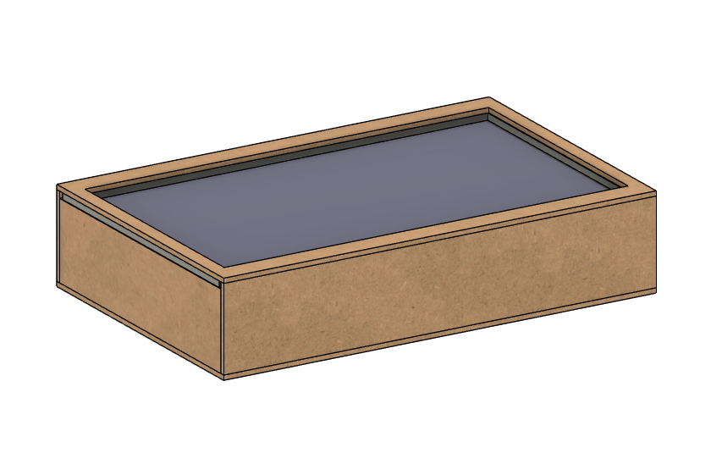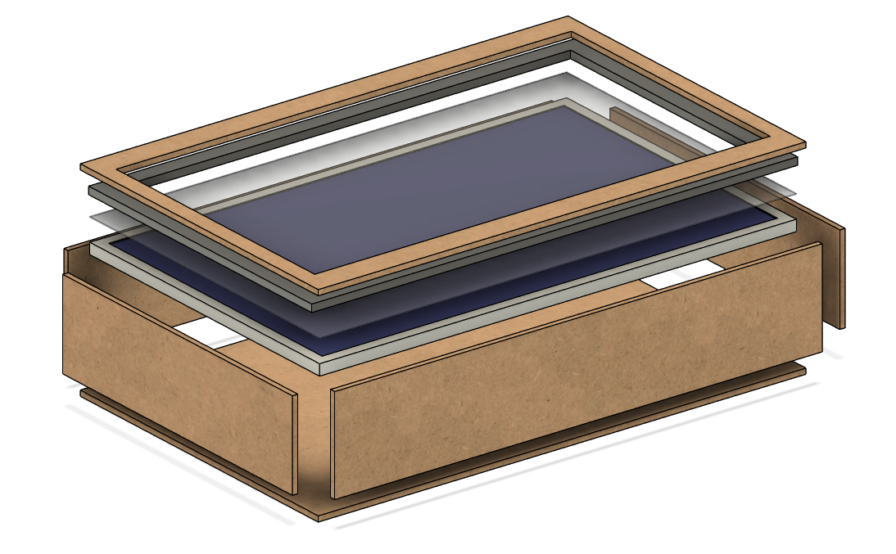

1. **Tasks**

| **1 - Idea development** | | |
| --- | --- | --- |
| **Task** | **Assigned to** | **Due Date** |
| Come up with the dimensions of the design. | Alan | 4/11/22 (after meeting) |
| CAD the dimension Alan provides | Gabriel | 4/12/22 |
| Begin assembly | Everyone | 4/12/22 |
|  |  |  |

1. **Work Distribution**

| **Alan Palayil** | Disassembled the monitor and speaker to have a sleek design for the final product. |
| --- | --- |
| **Fabian Garcia** |  |
| **Gabriel Gutierrez** | Will begin adding detail to the 3D cad model once the team meets in person |

1. **Progress and Milestones**

We have come up with an expected timeline for the final 441 presentations. Our priorities are in the following order:

1. Enclosure
2. Get LEDS operational
3. Install some apps to the new OS
4. **Next Steps**

Begin designing our enclosure on 4/11/2022

Being working on the final presentation and video